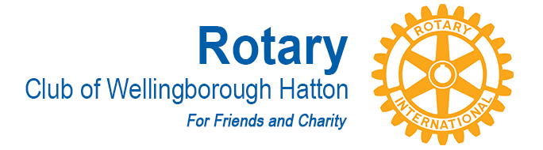
CHAIRMAN: Richard Brooks VICE CHAIRMAN: Dave Smith
COMMITTEE: International
AGM MEETING DATE: 15 May 2018
KEY PROJECTS:

- The Fun Day in June 2017 was a great success with a surplus raised of approximately £ 3000
During the year we donated £ 250 to Water Aid

We also donated £ 590 to replace a Shelter Box

The £ 1000 we donated to Oadby Club’s Jaipur Limb workshop was finally paid in May 17 and does therefore not come into this year.

